1. Created Linux Instance named LINUX SERVER

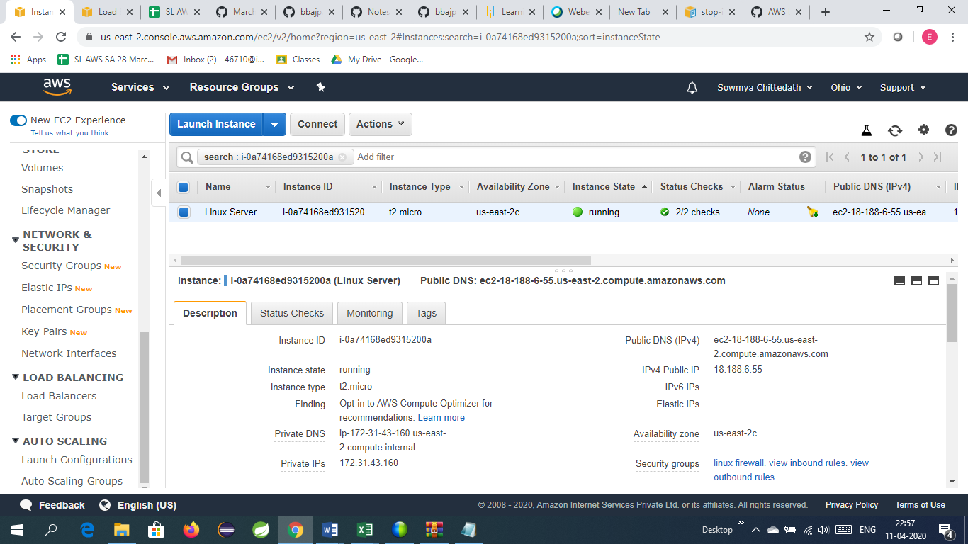

1. Create AMI of this server

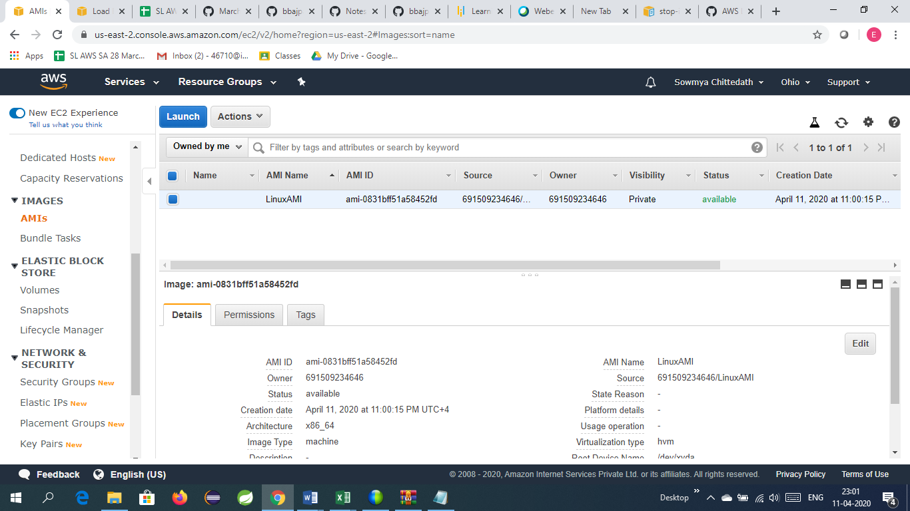

1. Create Load Balancer with no instances

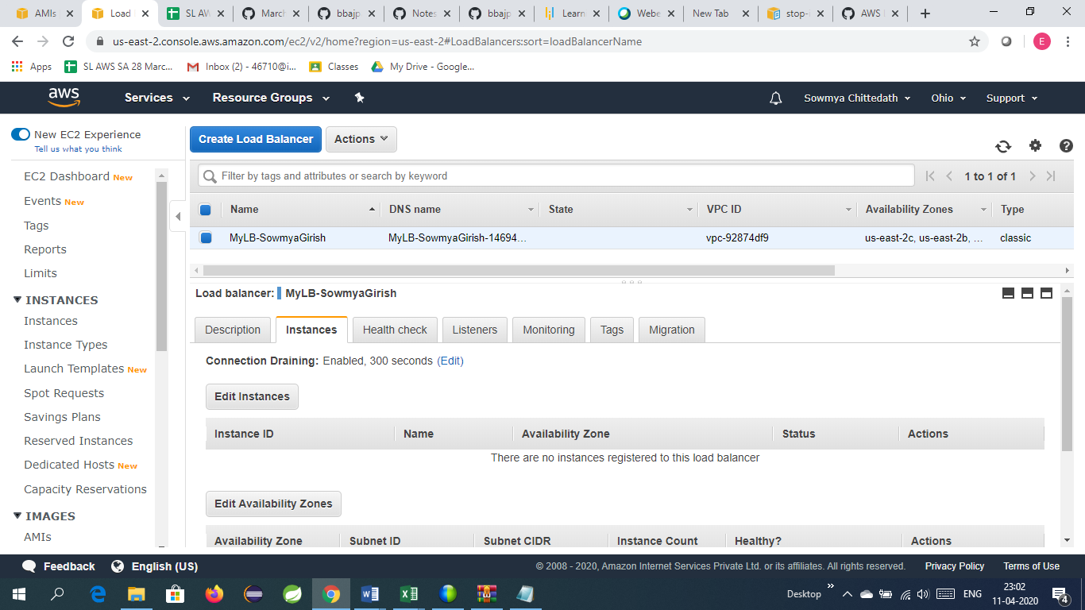

1. Create Launch Configuration

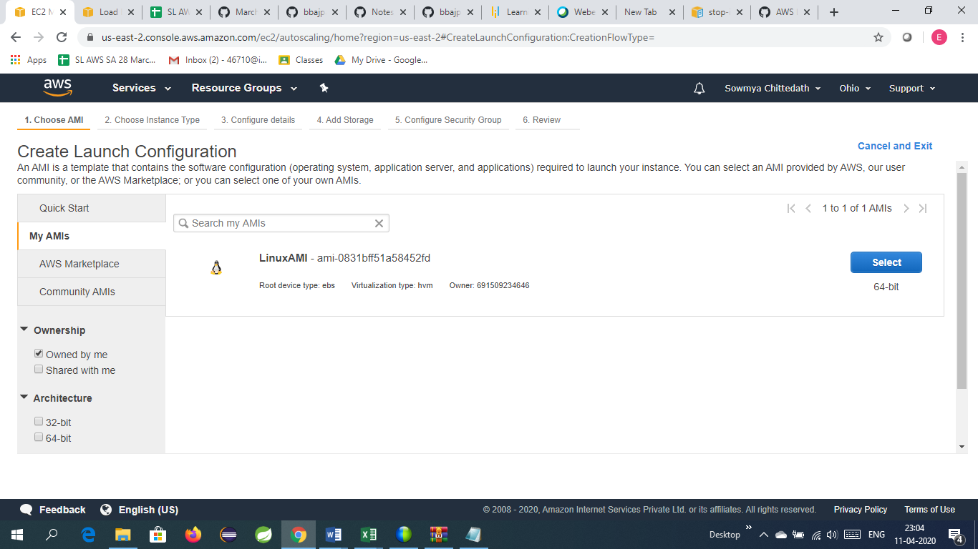

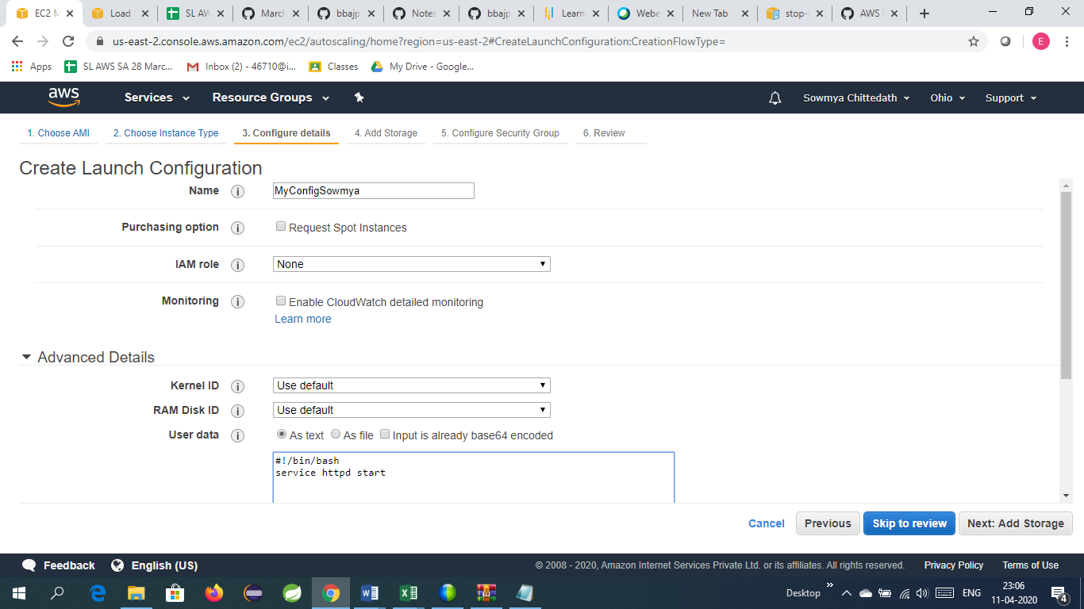

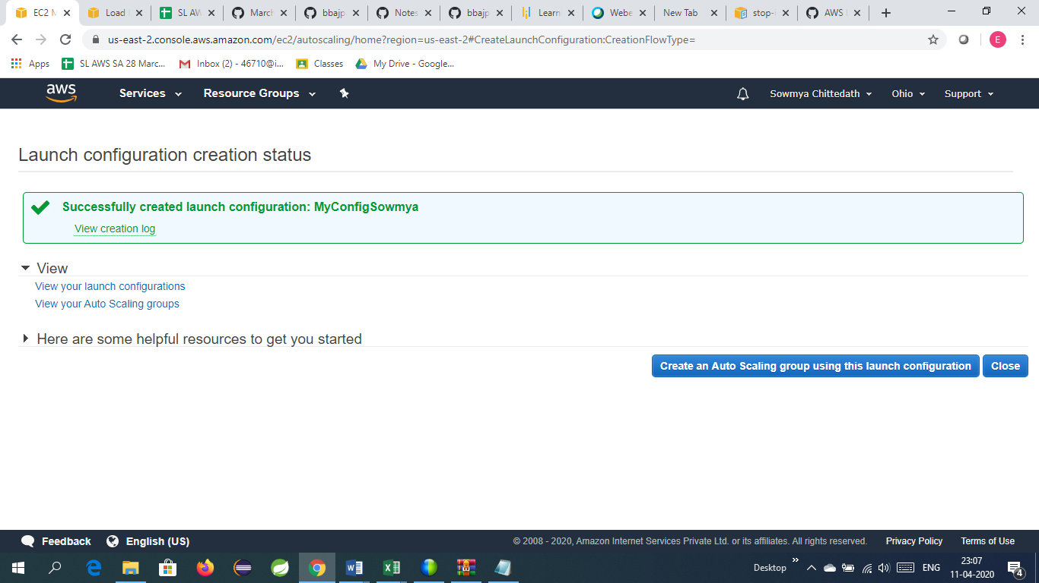

1. Create Auto Scaling Group

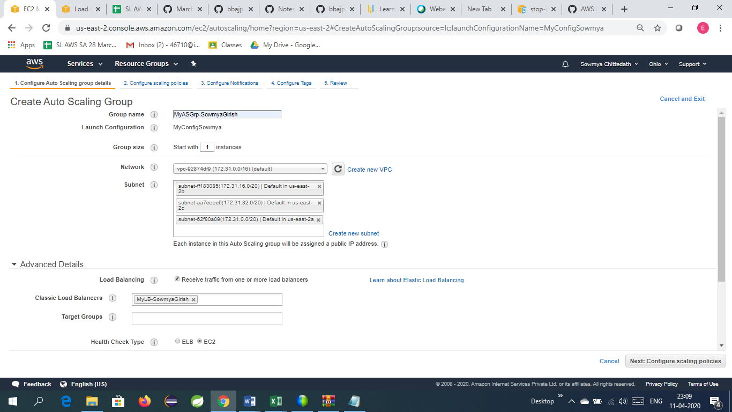

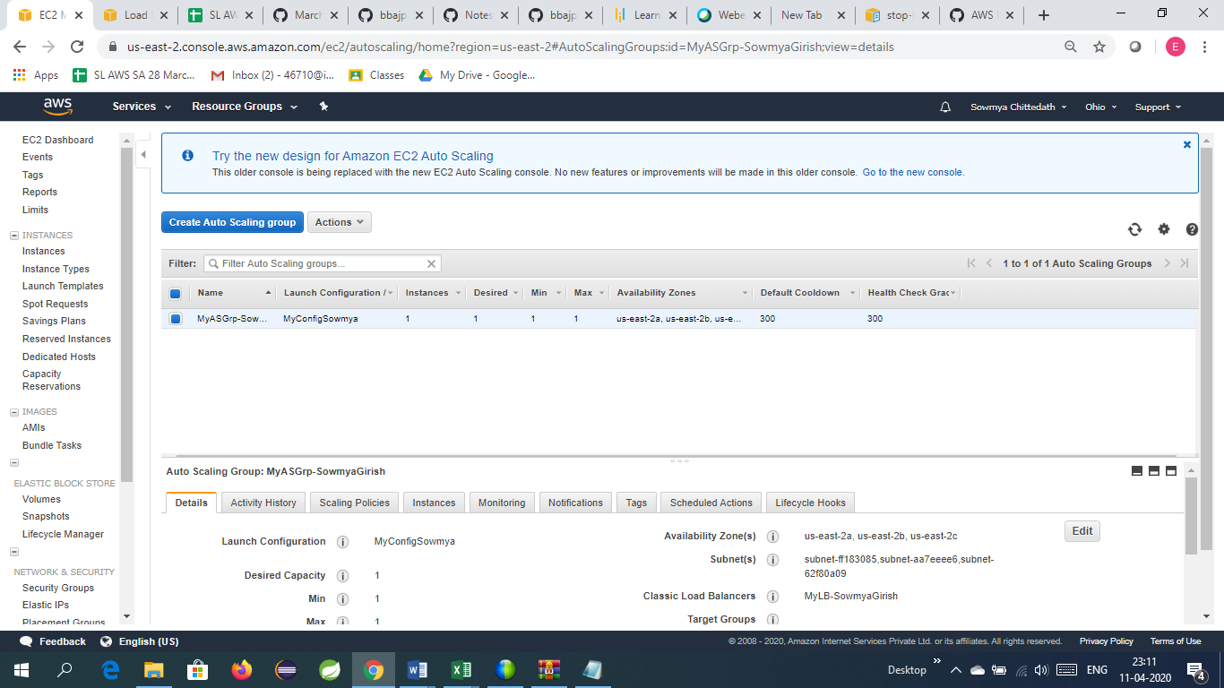

1. Add the scaling policies

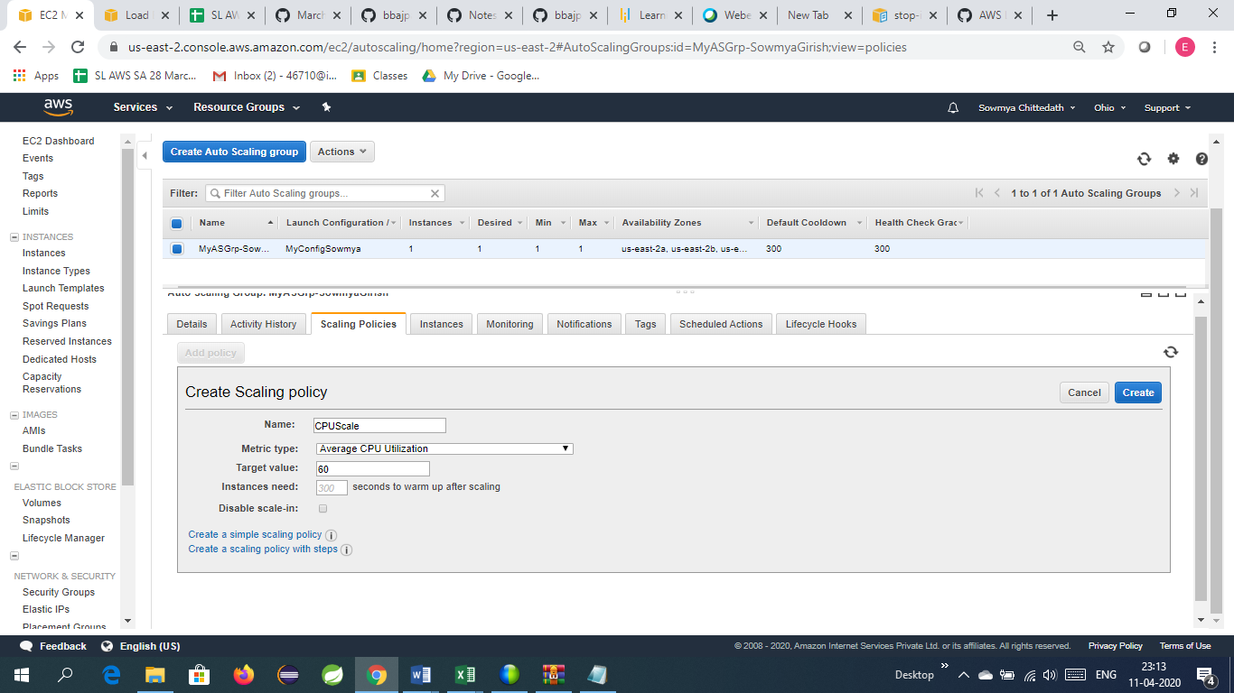

1. Edit the scaling group

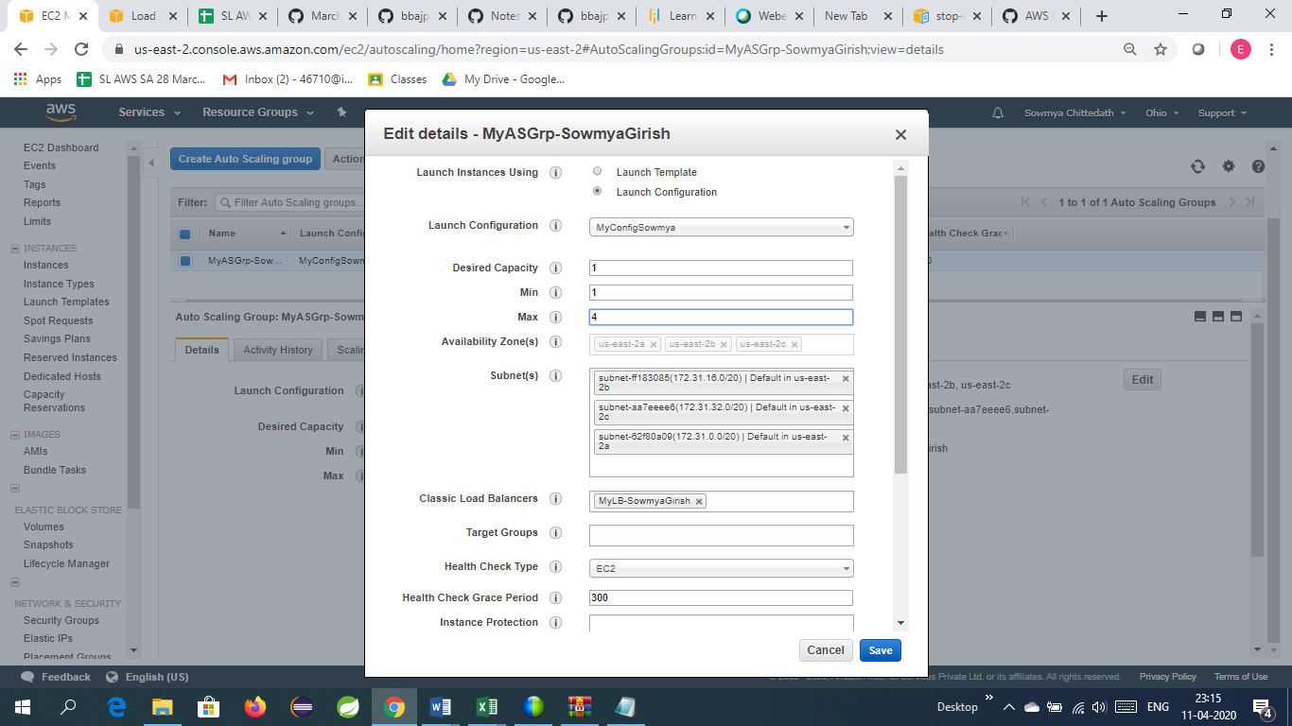

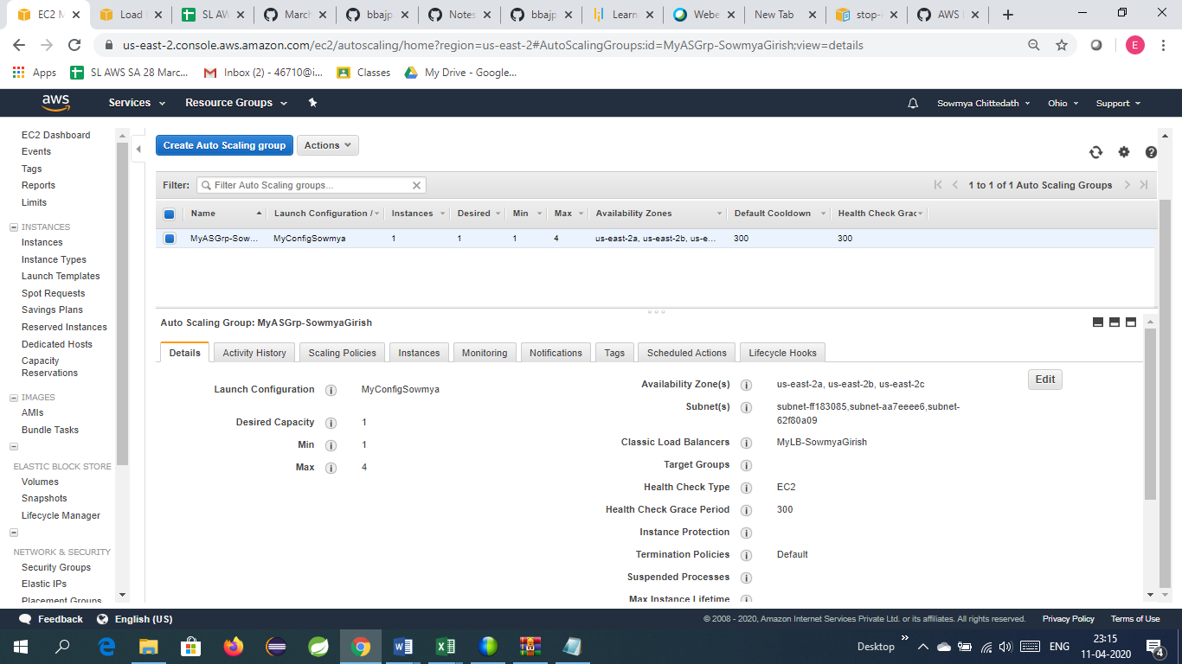

1. Auto Scaling server is running

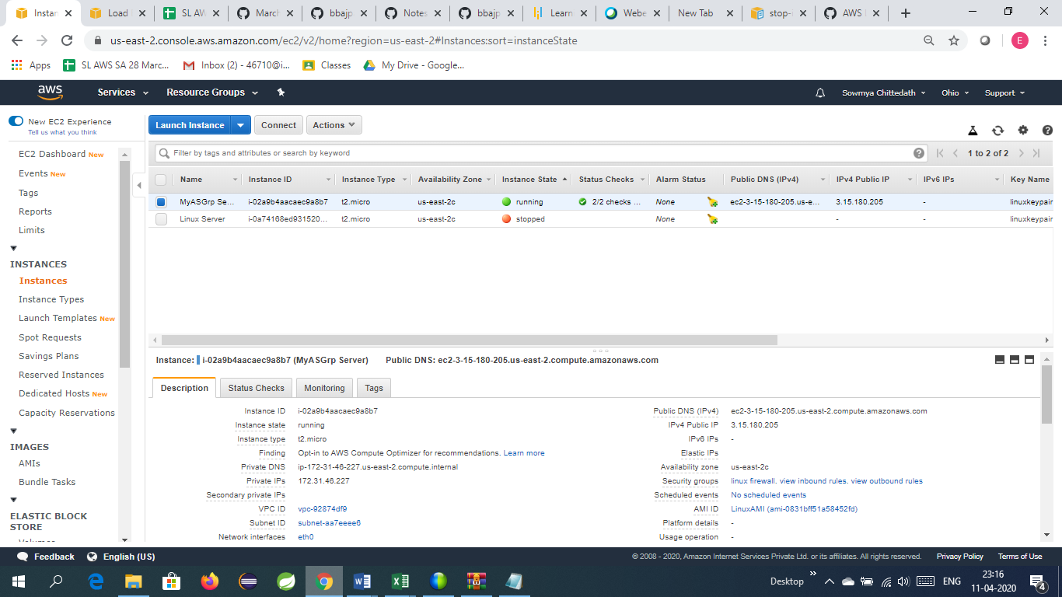

Connect to this server and install stress in it

Command to install stress : yum install stress –y

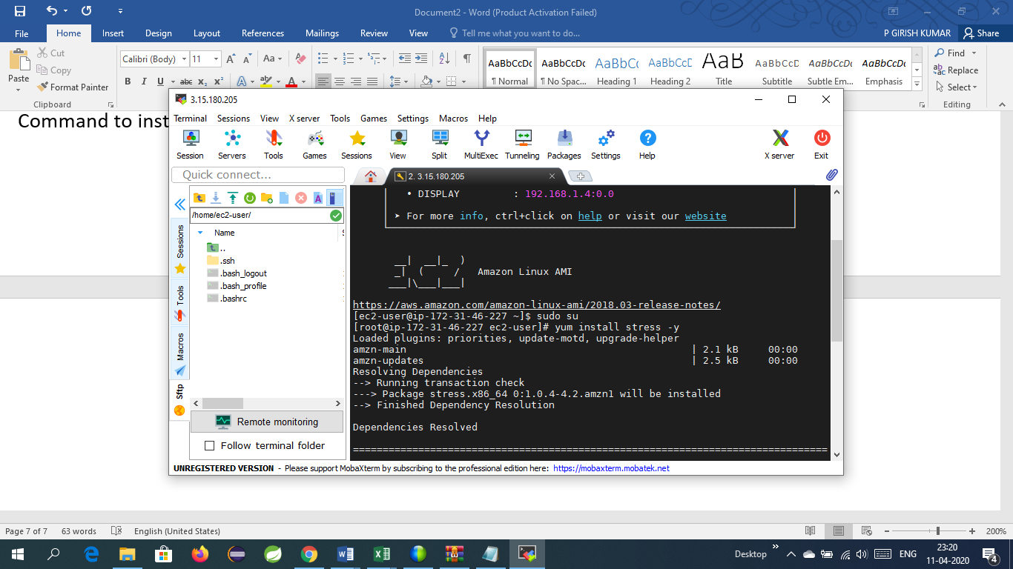

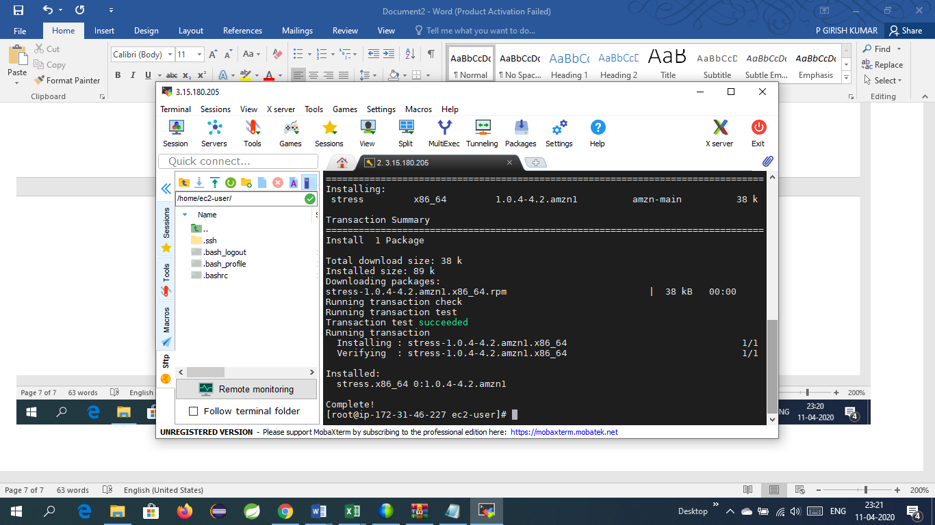

Real time load on cpu before starting stress is less than 1%

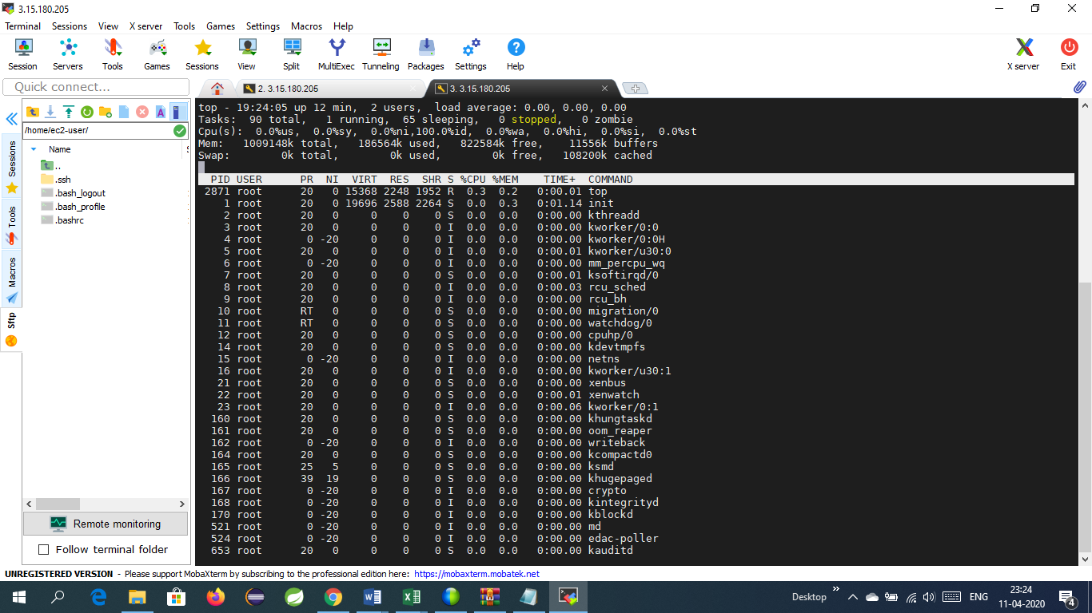

Also the CloudWatchmetrics shows less than 1%

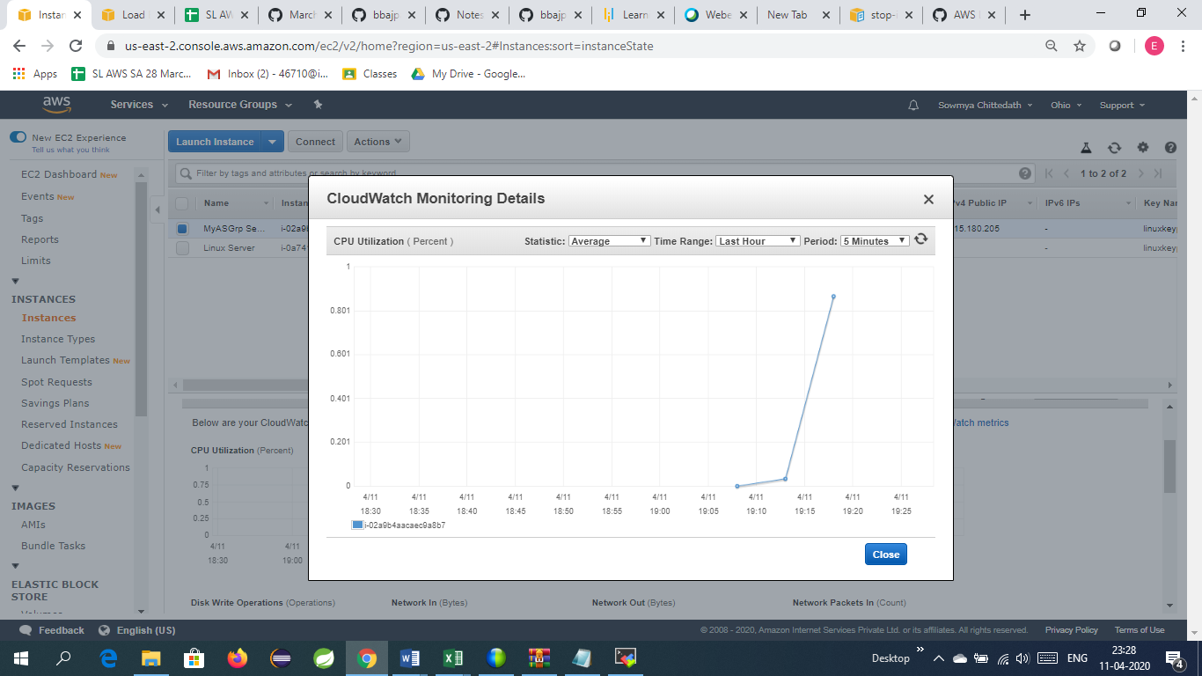

Start stress using the command

Stress –c 4

Now the real time CPU Utilization is 100%

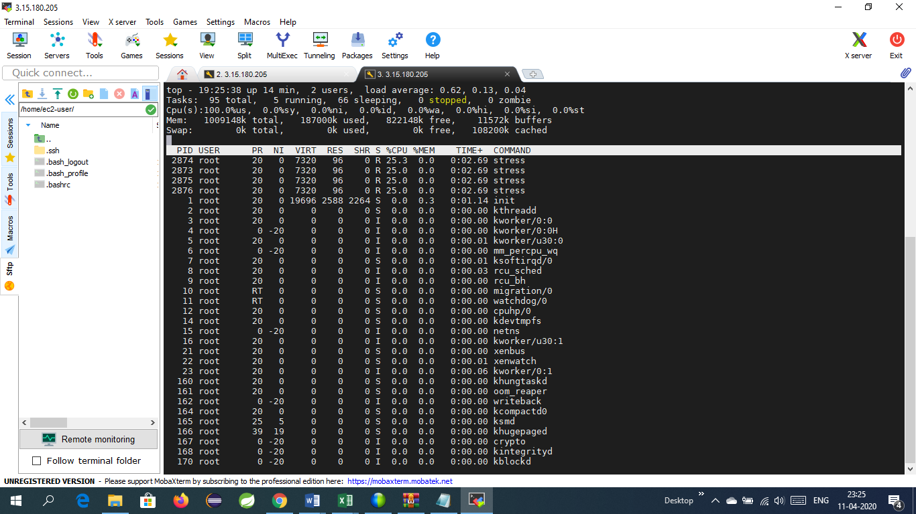

After five minutes the CloudWatch Metrics shows the increase in CPU Utilization

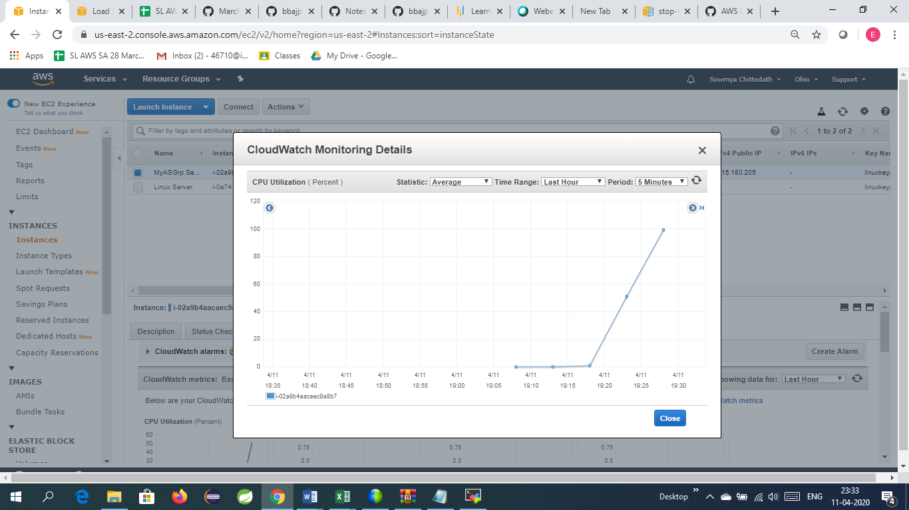

Now the servers are getting scaled up automatically using autoscaling group (Max up to 4)

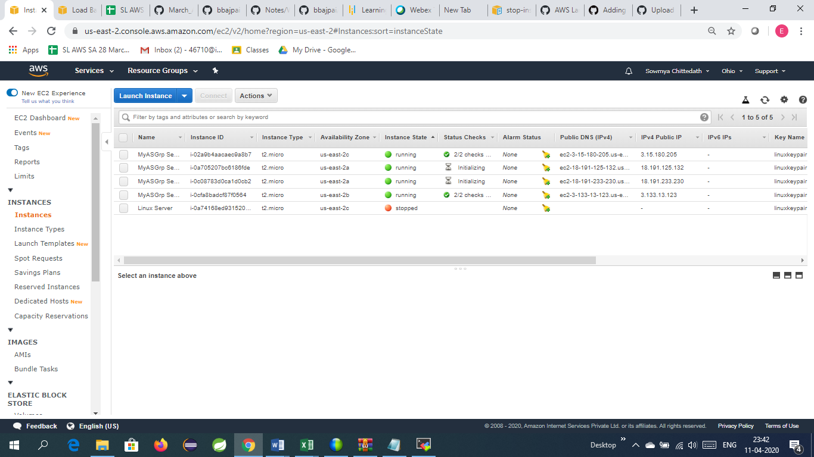

Auto Scaling group show the following instances

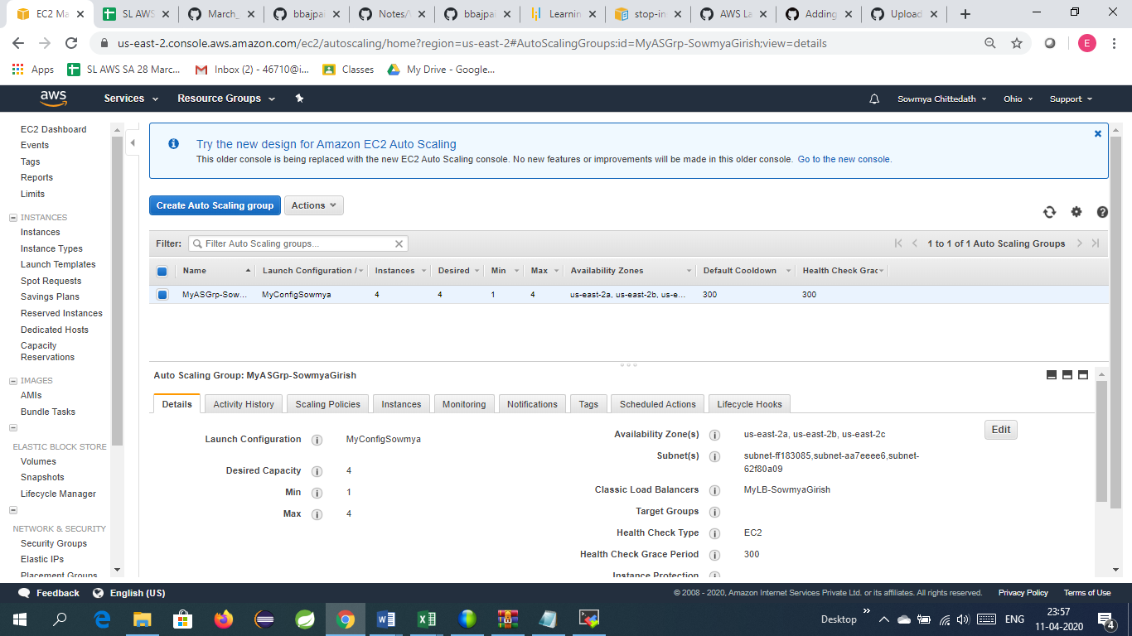

After stopping the stress using Ctrl+C the CPU Utilization is reduced to less than 1%

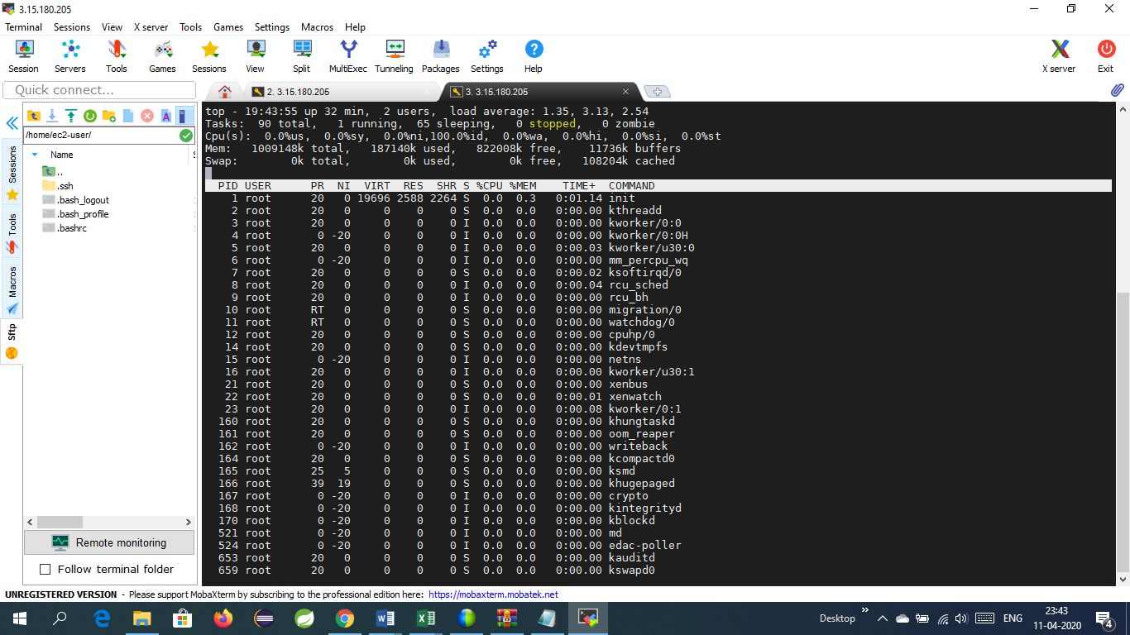

Cloud Watch Metrics

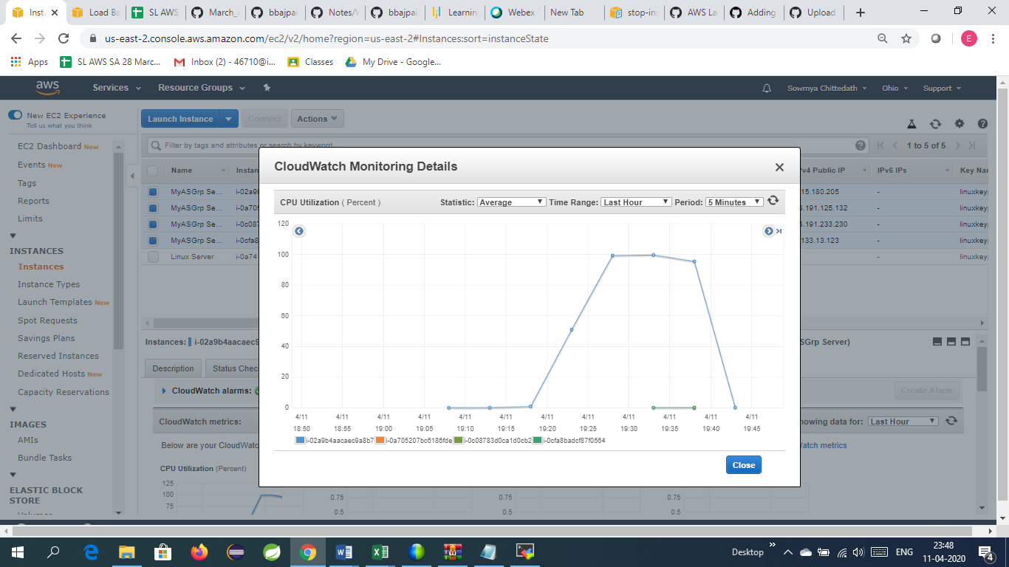

Now the number of instances will reduce to minimum ie. 1 terminating the other three servers.

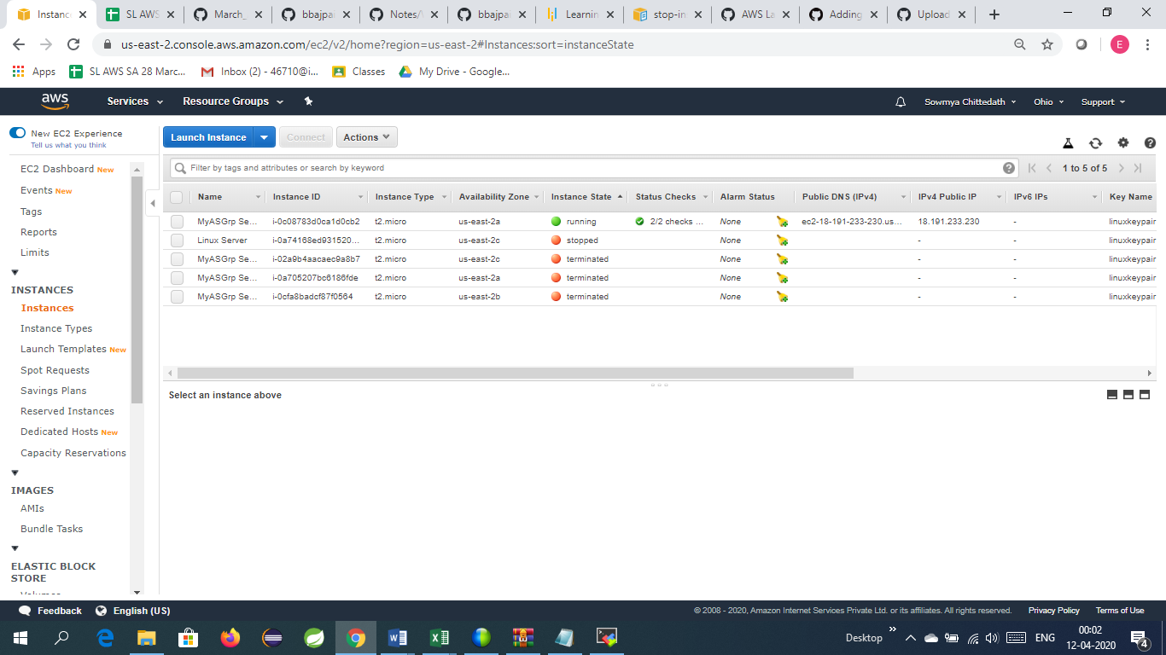

Thus AutoScaling can be achieved using stress through dynamic scaling policy